**Engagement Schedule / GSA / Change request**

**What is Engagement Schedule no 61**: SOW is created for every process. Engagement schedule is bigger umbrella or topic then SOW. Engagement schedule need not be created regularly. It is a broad document that is created & under it we keep on adding SOWs. Then it becomes easier.

This document states that whatever business they are providing us will be part of this engagement schedule. It is more detailed than the SOW.

**GSA: General Services Agreement::** is the initial agreement that is done with Prudential which has most of the details. Whenever we are doing SOW & Engagement schedule , this document might come into picture. This is not that much required for a Transition manager but he should eb aware about it.

**Pricing details in GSA:** Pricing details can be found in GSA. This is there in 103 page.

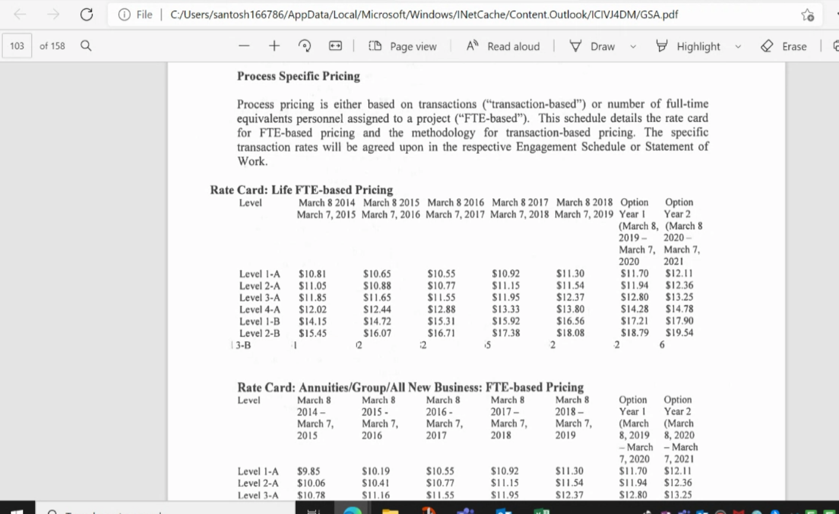

**General Note:** All documents created in a transition will be in line with GSA or Engagement schedule.

**Change Request**: If there is any change required to SOW then it is done through a change request.

Note: on Due diligence: Sometimes the transition manager takes along documentation team or sometimes he goes alone. Transition manager does not do any testing , it is our colleagues that do it for us. Our job is to maintain an oversight to make this transition a success whether it is assessments, SOP , whether AM s are facing challenges, u can ask whether the client can create a quiz,